ULTRA BOOK CLUB – TICKET A
Name:________________________ Book: __________________________
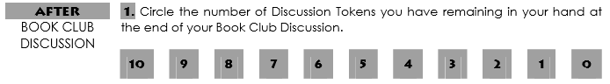
Due Date: ____________________ Pages: _________________________

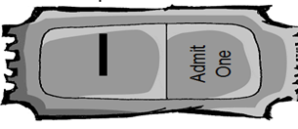
EVIDENCE (Text Clues) |  | CONCLUSIONS (Inferences)
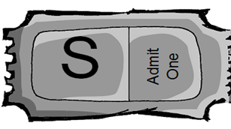
SUMMARY SNAPSHOTS
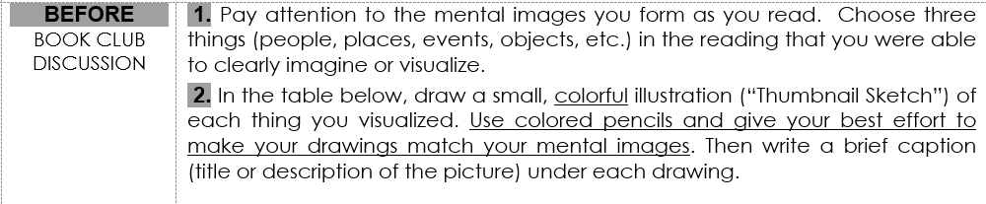
CAPTION | THUMBNAIL SKETCH
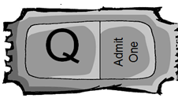 | 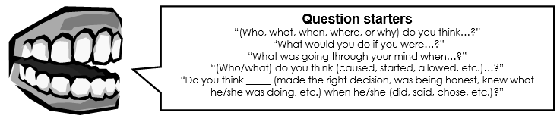
QUESTION
WRITTEN REFLECTION
- Explain what you learned about the book from others in your group.
- Describe the most interesting topic and explain why you found that topic interesting.
_____________________________________________________________________________________________________________________________________________________________________________________________________________________________________________________________________________________________________________________________________________________________________________________________________________________________________________________________________________________________

