ULTRA BOOK CLUB – TICKET B
Name:________________________ Book: __________________________
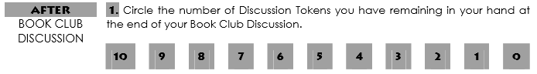
Due Date: ____________________ Pages: _________________________

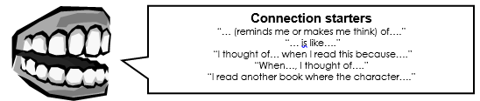
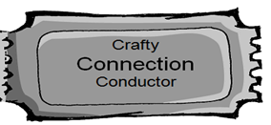
Page /  Paragraph | Type of Connection | CONNECTION
_____ | TEXT-TO-SELF  TEXT-TO-WORLD  TEXT-TO-TEXT
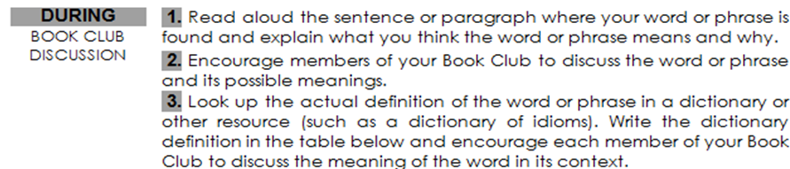
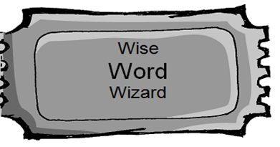
Word or Page/  Phrase Paragraph | WHAT I THINK IT MEANS  -using clues | DICTIONARY DEFINITION
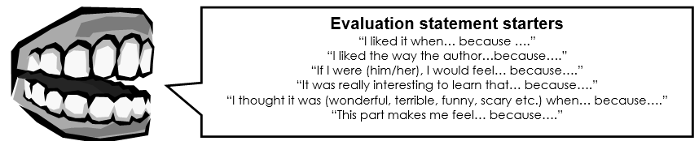
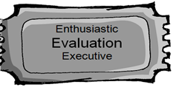
Page/Paragraph | EVALUATIONS
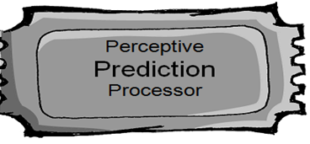 | 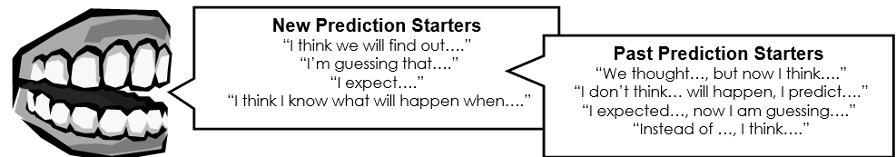
type of prediction | PREDICTION
MAKING A NEW PREDICTION

REVISING A PAST
PREDICTION
WRITTEN REFLECTION
- Explain what you learned about the book from others in your group.
- Describe the most interesting topic and explain why you found that topic interesting.
________________________________________________________________________________________________________________________________________________________________________________________________________________________________________________________________________________________________________________________________________________________________________________________________________________________________________

