Top 10 Worldwide Restaurant List:

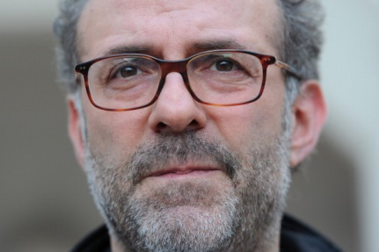
#1. Osteria Francescana, Modena, Italy
Chef: Massimo Bottura
Last year's rank: 2
Average cost: Cost: €180-€200 (USD $234-$260).
Photo: Carl Court/AFP/GettyImages
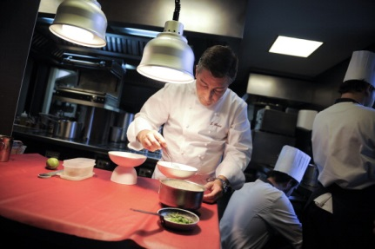
2. El Celler de Can Roca, Girona, Spain
Chef: Joan Roca
Last year's rank: 1
Average cost: €165-€195 (USD $184-$218)* 2015 pricing.
Photo: David Ramos/Getty Images

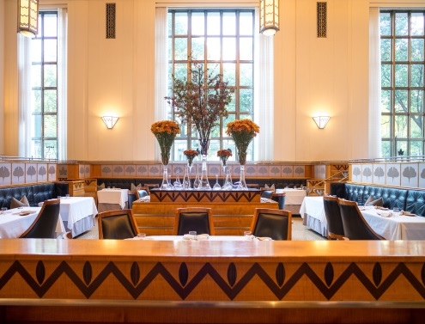
3. Eleven Madison Park, New York City
Chef: Daniel Humm
Last year's rank: 5
Cost: $295, service-included.
Photo: Nick Solares/Eater
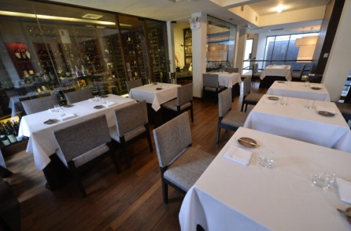
4. Central, Lima
Chef: Virgilio Martinez and Pia Leon
Last year's rank: 4
Average cost: s/319-s/398 (USD: $95-$119).
Photo: Cris Bouroncle/AFP/Getty Images

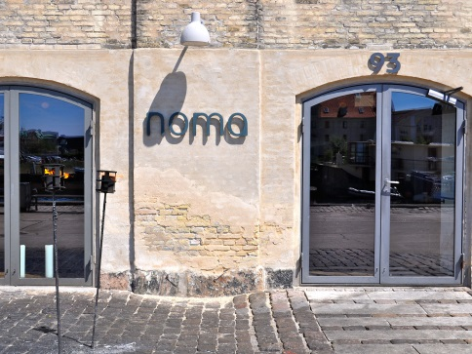
5. Noma, Copenhagen
Chef: René Redzepi
Last year's rank: 2
Cost: 1900 DKK (USD: $289).
Photo: sackerman/Flickr
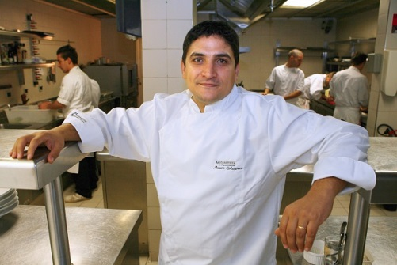
6. Mirazur, Menton, France
Chef: Mauro Colagreco
Last year's rank: 11
Average cost: €85-€210 (USD: $110-$273)
Photo: Yoshikazu Tsuno/AFP/Getty Images

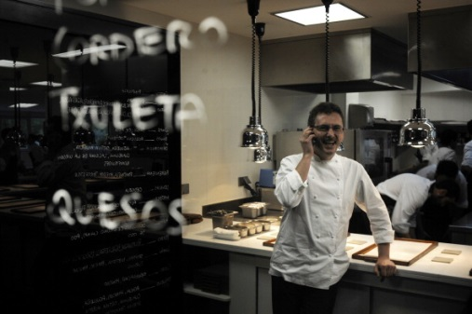
7. Mugaritz, Errenteria, Spain
Chef: Andoni Luis Aduriz
Last year's rank: 6
Cost: €185 (USD: $240)
Photo: Rafa Rivas/AFP/Getty Images
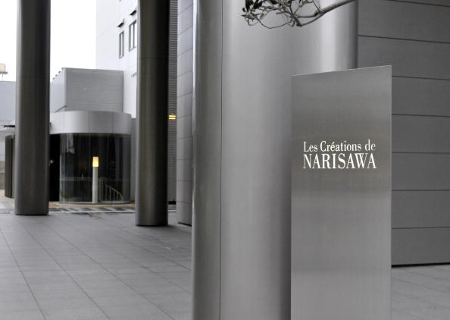
8. Narisawa, Tokyo
Chef: Yoshihiro Narisawa
Last year's rank: 8
Cost: ¥25000 (USD: $233).
Photo: Yoshikazu Tsuno/AFP/Getty Images
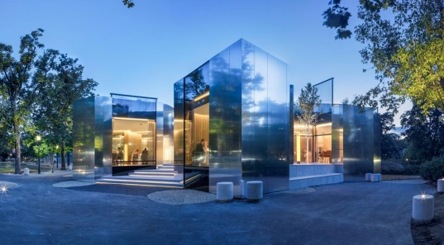
9. Steirereck, Vienna, Austria
Last year's rank: 15
Average cost: €132-€142 ($171-$184)
Photo: Facebook
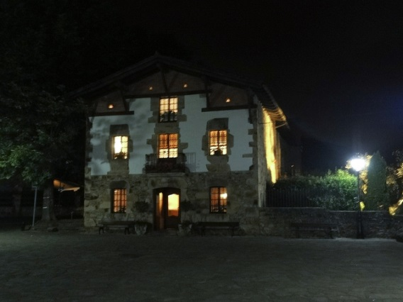
10. Asador Etxebarri, Axpe, Spain
Last year's rank: 13
Cost: €135 (USD $175)
Photo: Flickr

