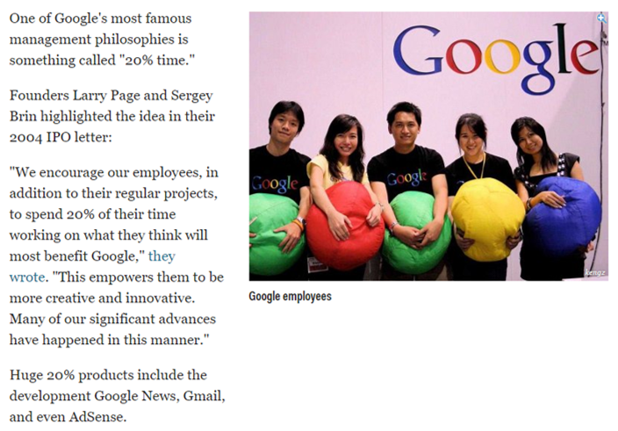

http://www.businessinsider.com/google-20-percent-time-policy-2015-4

