NAME DATE
4th GRADE AIM
GENIUS HOUR REFLECTION

PROJECT TITLE –___________________________________________________
WHAT DID I DO THIS WEEK? – What work have you done on your Genius Hour project over the past week? How much time did you spend on your Genius Hour project?
___________________________________________________________________________________________________________________________________________________________________________________________________________________________________________________________________________________________________________________________
WHAT DID I LEARN THIS WEEK?–
____________________________________________________________________________________________________________________________________________________________________________________________________________________________________________________________ _______________________________________________________________
ADJUSTMENTS – Some questions I have, or some things I need to improve are:
_____________________________________________________________________________________________________________________________________________________________________________________________
RESOURCES I USED THIS WEEK:
Website: ____________________________________________________________________________________________ Website: _________________________________________________________ Book (and Author): ___________________________________________________ Book (and Author): ___________________________________________________
Other: ______________________________________________________________________________________________
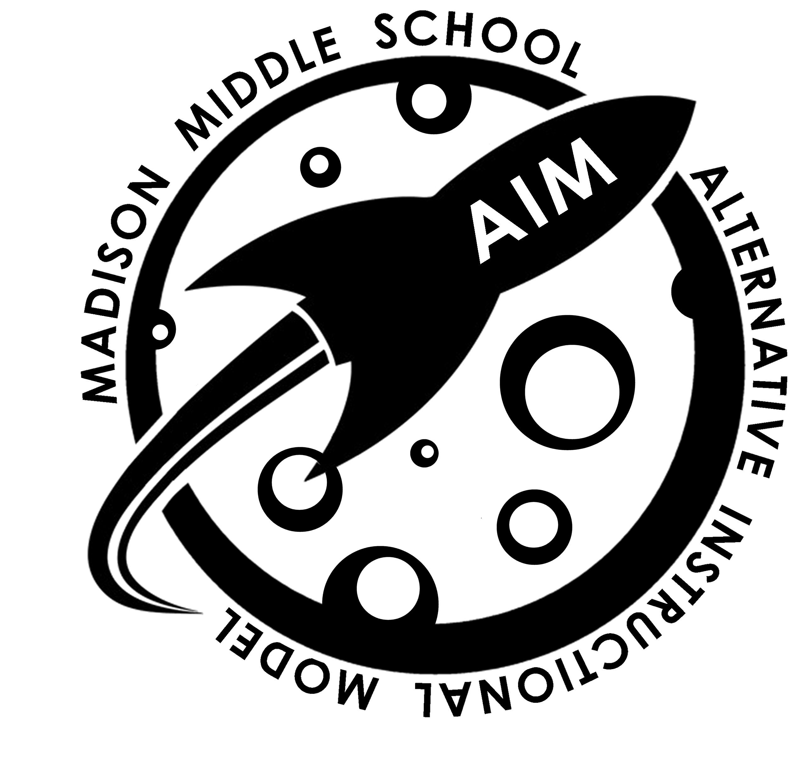
WHAT’S NEXT? – What kinds of help or tools do you need to move forward?
______________________________________________________________________________________________________________________________________________________________________________

