Beginner's Guide to Oil Painting: Part 2

Get Ready to Paint!
Get ready to learn how to prepare a canvas for oil painting, decide on a subject, and learn an easy technique to transfer a sketch from a drawing pad onto a blank canvas!

What You'll Need
- Canvas
- Gesso
- Soft paintbrush (¾” to 1” thick)
- Small plastic container
- Something to cover your work surface (ex. an old pillowcase, paper towels)

What Is Gesso?
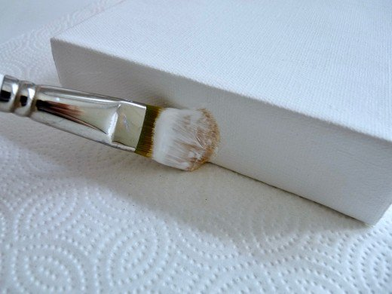
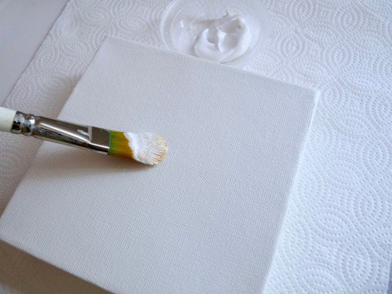
Gesso is an acrylic-based primer that will make the oil paints grip the surface of the canvas better. Even if the canvas you bought says it’s pre-primed, adding a coat of gesso will make a huge difference in how your paint goes on the canvas. Gesso is water-soluble and, unlike oil paints, you can clean gesso off your paintbrush with water and a gentle soap.

Take your time and apply the gesso in neat, smooth strokes. Don't forget the sides of the canvas if you plan to paint them too.

Prime Your Canvas

Here's how to prime your canvas so it's ready to paint:
- Place the canvas on a covered work surface.
- Put a little gesso into you small plastic container.
- Dampen your paintbrush.
- Begin applying the gesso in neat, even, horizontal strokes across the canvas.
- You can re-dampen your paintbrush during this process if needed, but don’t over-thin the gesso with water. Also, don’t apply the gesso too thickly—otherwise, it may crack when it's dry. A light coat is perfect.
- Clean your brush with lukewarm water and a gentle soap as soon as you’re finished with the gesso. I like using either a dishwashing soap like Dawn or an art brush soap.
- Gently rinse your brush well until all the gesso comes out. Put it on a paper towel to dry. If the brush isn’t thoroughly cleaned and rinsed, the gesso will harden as it dries, and the brush may be ruined.
When you’ve covered the entire surface of the canvas with gesso, check to make sure everything looks nice and smooth.
- If needed, make a few quick touch-ups, but work quickly because once the gesso starts to dry, going over it repeatedly will smudge the surface.
- If you have a thick canvas with staple-free edges, apply the gesso to the sides too.
Once the gesso has been applied, your canvas should look similar to the photo above. Allow the canvas to dry for 24 hours before you paint on it.

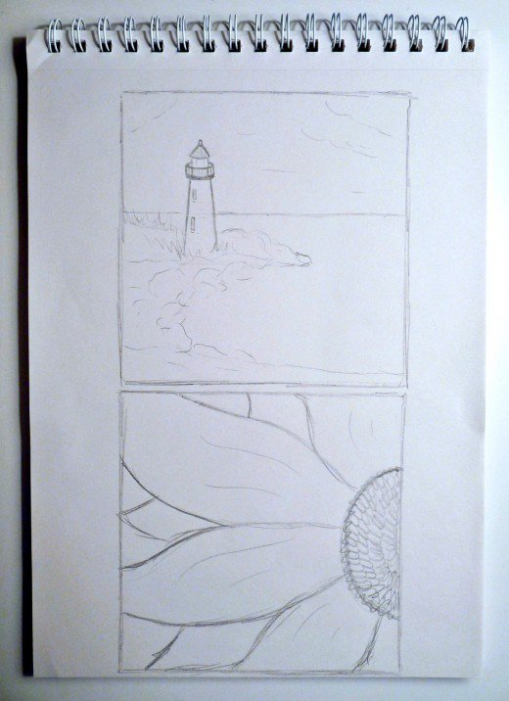
As a new oil painter, a blank canvas can be intimidating. A sketch pad is a good way to do a 'rough draft' of your painting before you work with your paints on the canvas. Outline the small canvas on a sketch pad as a guide.

2. Decide on a Subject for Your Oil Painting
What you paint is entirely up to you. I sometimes find it helpful to make a few rough sketches on a sketchpad to plan out my painting in advance.
To make sure my sketch fits the canvas I plan to use, I trace the actual canvas onto my sketchpad as a guide. Just make sure you’ve let your gesso on the canvas dry completely before you do this step.

3. Put Your Pencil to Paper
Try as many sketches as you need until you find something you like.
Here are a few ideas to get you started:
- A colorful bowl of fruit on your table
- The scenery outside your window
- Your pet
- Flower
- Plant
- Something from your vacation photos
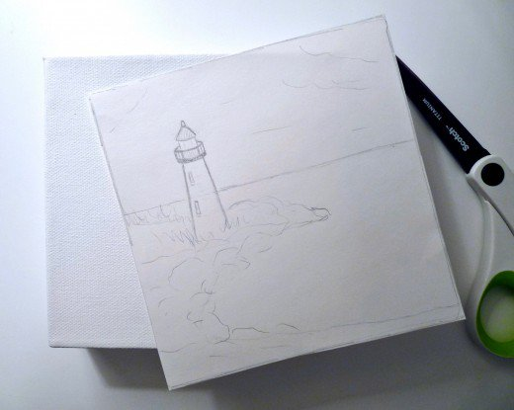
If you find something you like, you can either use it as a reference for your painting or trace it using tracing paper to transfer it to your canvas. If you prefer a more abstract design, skip this step and move onto the painting. If you plan to use a sketch, here are the steps for transferring your pencil sketch from your pad onto your canvas.

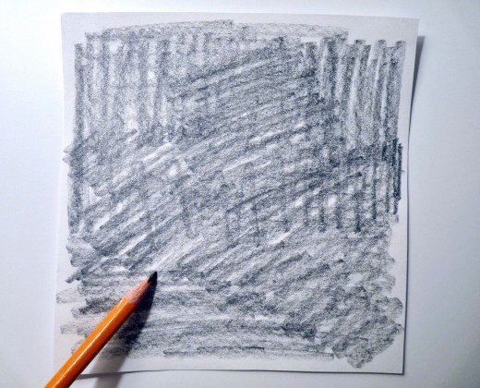
4. Cut the Sketch
Once you've decided on a sketch, neatly cut it out using your trace marks as a guide.

Darken the back of your sketch with the sides of your pencil.

9

- FeltMagnet»
- Painting»
- Oils

Beginner's Guide to Oil Painting: Part 2
Updated on May 28, 2018
carolynkaye
more

I’ve been drawing and painting for most of my life and love sharing tutorials and tips to help anyone who wants to learn about art.
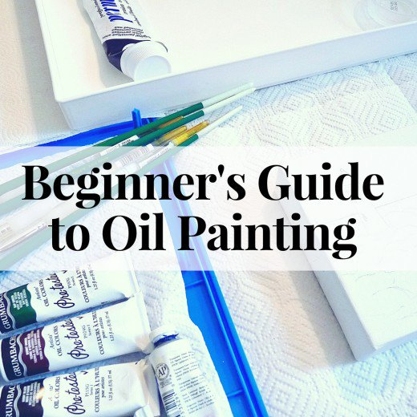
Source

Get Ready to Paint!
Get ready to learn how to prepare a canvas for oil painting, decide on a subject, and learn an easy technique to transfer a sketch from a drawing pad onto a blank canvas!

What You'll Need
- Canvas
- Gesso
- Soft paintbrush (¾” to 1” thick)
- Small plastic container
- Something to cover your work surface (ex. an old pillowcase, paper towels)

What Is Gesso?
Gesso is an acrylic-based primer that will make the oil paints grip the surface of the canvas better. Even if the canvas you bought says it’s pre-primed, adding a coat of gesso will make a huge difference in how your paint goes on the canvas. Gesso is water-soluble and, unlike oil paints, you can clean gesso off your paintbrush with water and a gentle soap.
Take your time and apply the gesso in neat, smooth strokes. | Source
Don't forget the sides of the canvas if you plan to paint them too. | Source

1. Prime Your Canvas

Here's how to prime your canvas so it's ready to paint:
- Place the canvas on a covered work surface.
- Put a little gesso into you small plastic container.
- Dampen your paintbrush.
- Begin applying the gesso in neat, even, horizontal strokes across the canvas.
- You can re-dampen your paintbrush during this process if needed, but don’t over-thin the gesso with water. Also, don’t apply the gesso too thickly—otherwise, it may crack when it's dry. A light coat is perfect.
- Clean your brush with lukewarm water and a gentle soap as soon as you’re finished with the gesso. I like using either a dishwashing soap like Dawn or an art brush soap.
- Gently rinse your brush well until all the gesso comes out. Put it on a paper towel to dry. If the brush isn’t thoroughly cleaned and rinsed, the gesso will harden as it dries, and the brush may be ruined.
When you’ve covered the entire surface of the canvas with gesso, check to make sure everything looks nice and smooth.
- If needed, make a few quick touch-ups, but work quickly because once the gesso starts to dry, going over it repeatedly will smudge the surface.
- If you have a thick canvas with staple-free edges, apply the gesso to the sides too.
Once the gesso has been applied, your canvas should look similar to the photo above. Allow the canvas to dry for 24 hours before you paint on it.
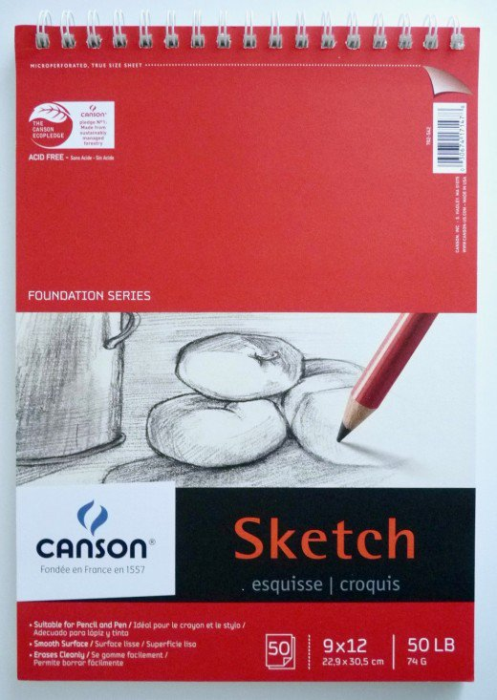
As a new oil painter, a blank canvas can be intimidating. A sketch pad is a good way to do a 'rough draft' of your painting before you work with your paints on the canvas. | Source
Outline the small canvas on a sketch pad as a guide. | Source

2. Decide on a Subject for Your Oil Painting
What you paint is entirely up to you. I sometimes find it helpful to make a few rough sketches on a sketchpad to plan out my painting in advance.
To make sure my sketch fits the canvas I plan to use, I trace the actual canvas onto my sketchpad as a guide. Just make sure you’ve let your gesso on the canvas dry completely before you do this step.
If you're not sure what to paint, try some pencil sketches on a pad to help plan out your painting and layout. | Source

3. Put Your Pencil to Paper
Try as many sketches as you need until you find something you like.
Here are a few ideas to get you started:
- A colorful bowl of fruit on your table
- The scenery outside your window
- Your pet
- Flower
- Plant
- Something from your vacation photos
If you find something you like, you can either use it as a reference for your painting or trace it using tracing paper to transfer it to your canvas. If you prefer a more abstract design, skip this step and move onto the painting. If you plan to use a sketch, here are the steps for transferring your pencil sketch from your pad onto your canvas.

4. Cut the Sketch
Once you've decided on a sketch, neatly cut it out using your trace marks as a guide.

Darken the back of your sketch with the sides of your pencil. | Source

5. Darken the Back
Flip the sketch over. Use the side edge of the pencil to darken the back of your drawing.

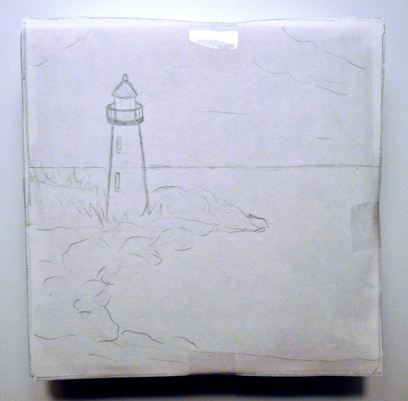
Sketch taped onto canvas

6. Tape the Sketch
After the back is darkened, tape the sketch front-side up onto the canvas so it stays in place for the next step. Make sure it’s lined up straight because this is how your final image will be positioned on the canvas.

Trace sketch with ballpoint pen to transfer design

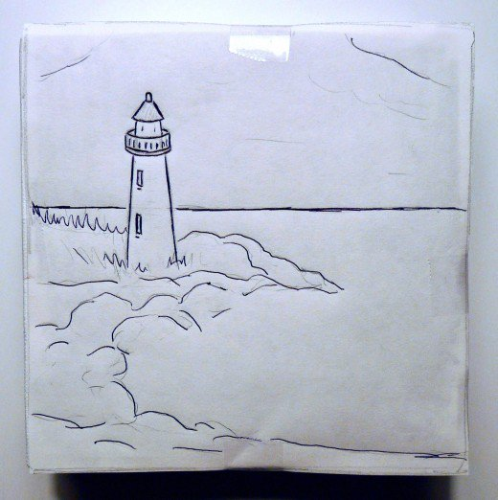

7. Trace Your Drawing
Once it’s securely taped, use a ballpoint pen to trace over all the lines of your sketch. Press hard enough to transfer the design but not so hard you tear your paper. Be sure all your pencil marks are covered with pen so you don’t miss anything.

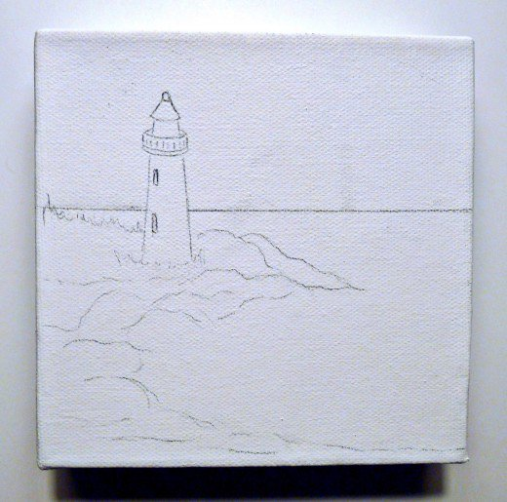
Now You're Ready to Start Painting!

