Beginner's Guide to Oil Painting: Part 1

Are You Ready to Oil Paint?
Whether you're brand new to painting or have already painted in other mediums such as watercolors or acrylics, you'll find that working with oil paints is definitely fun but takes some practice.
Artists love oil paints for their rich colors, durability, and their slow drying time, which allows plenty of time to work on a painting.
Even if you have no background in art, these simple, easy-to-follow steps can get you on your way to creating your first oil painting.

What Oil Painting Supplies Do I Need?
You can find all of these supplies at your local arts & crafts store, art supply store, or an online art store like DickBlick.com, JerrysArtarama.com or Utrechtart.com.
You don’t need to purchase the exact brands I show. This is just to give you an idea of what you should be looking for.
- Stretched Canvas
- Gesso
- Paint Brushes suited for Oil Painting
- Oil Paints
- Covered Palette
- Oil Painting Mediums
- Turpenoid
- Small Easel
- Sketch Pad

Canvas for Oil Painting
For your first painting, it's easiest to choose a fairly small stretched canvas with staple-free edges that you can display without a frame.
The small square canvas shown below is 5.5” x 5.5” and about 1.25” thick. It’s from the Squangles line at Darice.com. I like these little canvases for a few reasons:
- They don’t need to be framed.
- They stand up on their own, so they make a pretty decoration for a dresser or table.
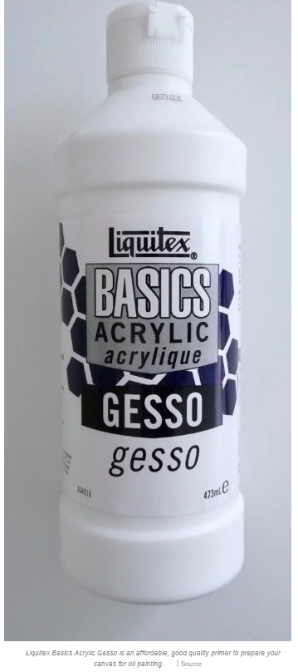
- Because you can paint the sides, the painting has a unique 3-D effect.
If you can’t find this exact size, a similar size canvas works just as well.

Gesso
Gesso is an acrylic-based primer that you will need to prime your canvas. It helps the paint “stick” to the canvas much better. You only need a small bottle of gesso when you’re just starting out—A little goes a long way, and you won’t need much to prime a small canvas.

Paint Brushes for Oil Painting
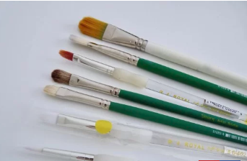
For a small painting, you’ll only need about four to six brushes of various sizes. Be sure to choose ones that say they’re suitable for oil painting so the bristles can handle the paint and solvents.
Choose a selection of small to medium-size brushes. You will need a few with rounded edges for smooth strokes and shading, a couple with square edges for crisp lines, and at least one slim pointed brush for tiny details.
Either natural or synthetic bristles are fine. Brushes can either be purchased individually or in sets. Brushes can get pricy, so use student quality ones if needed.

Oil Paints for Beginners
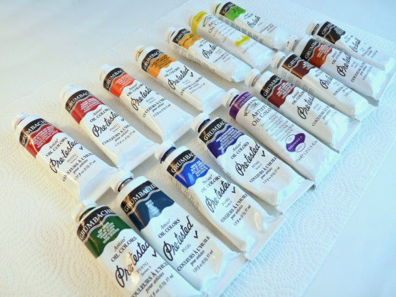
It’s up to you whether you'd like to buy a set of oil paints with a pre-selected assortment of colors or purchase tubes individually.
For those just starting out in oil painting, student paint sets are a good option. Two of my favorites are the Grumbacher Academy Oil Paint 10 Color Set and the Gamblin Artist Oil Colors Introductory Set. Both are high quality for the price and have a good selection of commonly used colors.
If you prefer to use artist quality oil paints, a few options are:
- Holbein Artists' Oil Colors
- Grumbacher Pre-Tested Artists’ Oil Colors
- Rembrandt Artists' Oil Colors.
Since most people use lots of white paint for mixing colors, I also suggest purchasing a tube of white Permalba in addition to a tube of white oil paint.

Covered Palette
A palette with a lid can be tightly sealed to keep air out and prevent your paints from hardening or drying out between painting sessions. Your tubes of oil paint will go much farther, and you won't be throwing out the excess each time you paint.
This is also a way to save time mixing paint because you can pick up right where you left off at your next painting session.

Oil Painting Mediums
Unlike acrylic paints or watercolors that can be thinned with water, oil paints must be mixed with a medium to help the paint flow on the canvas. There are many types of mediums to choose from depending on the type of effect you want.
To keep things simple for your first painting, I recommend trying either Liquin Original or Refined Linseed Oil. Liquin is great because it dries faster than an oil medium. Refined Linseed Oil slows the drying time and gives the paint a nice gloss.
- Purchase the smallest size bottle of either of these since you won’t need much for now.

Turpenoid: Clean Up After Oil Painting
When you’re done painting, you’ll need to clean your brushes thoroughly so they aren’t ruined by hardened paint. Water doesn’t dissolve oil paints, so you should consider purchasing a small bottle of Turpenoid. It’s a turpentine substitute that will clean your brushes and remove paint from surfaces.

Sketch Pad
A sketch pad is very helpful to plan out your painting before you begin. Either an 8”x10” or 9”x12” will work for this.
- I also recommend you have a pad of tracing paper on hand, either 8”x10” or 9”x12”.

Other Supplies for Oil Painting
Here are some other supplies that will help you get started with your painting:
- A pencil
- A ballpoint pen
- A soft gum eraser
- Scotch Tape
- A small glass container with a lid to store Turpenoid and soak brushes until you clean up
- A roll of paper towels
- A small plastic dish or cup for gesso
- A small plastic dish or cup for Liquin or Linseed Oil
- Some gentle dishwashing soap (like Dawn) or liquid hand soap
- Something to cover your work area, such as an old pillowcase or sheet
- An old apron or painting smock

