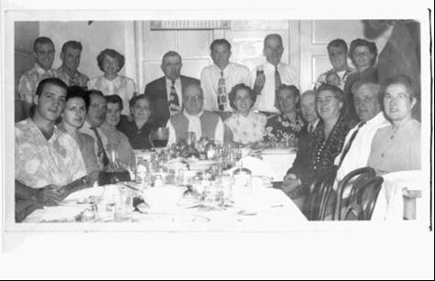
Basques in the American West: An annotated bibliography
by Sonja Humphries

TOPIC DESCRIPTION
America is the result of hundreds of years of immigration and settlement. In the mid 1800’s, the gold rush drew thousands of Basque people to the California wilderness and in the early 1900’s, ambitious youth of faraway lands rooted in the Pyrenees Mountains made their way to the Rocky Mountains of America’s West (Lasagabaster, 2008). Leaving homeland, family and friends behind in northern Spain, young men came with the intention of earning a nice wage and returning to their homeland to build lives there. During most of the eighteenth century and the early 1900’s, political unrest in the Basque Country broke the hearts and spirit of many, but in America, land was attainable at little cost and futures looked brighter, so young men sent for their sweethearts to join them or married local girls and invested in the uninhabited lands of California, Idaho, Wyoming, Oregon and Nevada; this was the beginning of the Basque diaspora in the American West.
The Basque Country is an autonomous country within France and Spain. Most migrants from Spain settled in America’s western territories before statehood was granted. Beginning in the mid 1800’s, young men journeyed to California to try their hand at gold mining, but it was difficult to make it worthwhile and living conditions were crowded. A few entrepreneurial men made the observation that miners had to eat, and much of the west was free for grazing, so they became sheepherders, which worked well for those who did not speak a language comprehensible to others of a different culture. Once the California Gold Rush fizzled out, the Basque sheepherders migrated to surrounding territories, which eventually became Nevada, Oregon, Idaho and Wyoming.
For nearly a century, young men journeyed west from their Basque homelands to herd sheep. Many non-Basque assumed that the Basque men preferred solitude, but the truth is that they found it difficult to communicate, as many Americans were immigrants from varying countries speaking in their native tongue, unbeknown to the Basque who believed everybody else was speaking English. Being a sheepherder eliminated the need to learn another language that seemed confusing and inconsistent. The sheep were taken to the hills during the spring and summer to graze on public lands, but during the winter months, the sheep were kept at sheep ranches, and these young men needed a place to eat and sleep. Basque hotels, or boardinghouses as they were called, erupted throughout densely populated areas to support the young bachelors. The boardinghouses became a home away from home as families would typically manage the boardinghouses. Tenants were like brothers forming family bonds with the master and mistress of the house as well. Eventually, young women came from Basque homelands and served as maids and cooks for the boardinghouses and young men found in them qualities of good mothers and wives. The Basque community was then perpetuated. Traditions have been preserved through social gatherings and Basque clubs, regional festivals, and programs of study supported by universities in the western states. The Basques of the American West are respected in the western states as being ambitious and hardworking and significant to the history of the West.

https://theidaholibrarian.wordpress.com/2012/05/09/basques-in-the-american-west-an-annotated-bibliography/

