NAME DATE
^{4th} GRADE AIM
GENIUS HOUR PROJECT PROPOSAL

TOPIC – What is your proposed topic or area of study?
____________________________________________________________________________________________________________________________________
GROUP SIZE – I will complete this project…
by myself
with a partner - _______________________________________________ (partner’s name)
with two partners - _________________________ ___________________________ (names)
TYPE OF PROJECT – For this project, I am going to…
learn about _________________________________________________________________________
learn how to ________________________________________________________________________
learn to test _________________________________________________________________________
learn to change _____________________________________________________________________
PURPOSE – Why do you want to pursue this project? Why is it beneficial? Why does it matter?
____________________________________________________________________________________________________________________________________________________________________________________________________________________________________________________________________________________________________________________________________________________________________________________________________________
PRIOR KNOWLEDGE – What do you already know about the topic you plan to study?
______________________________________________________________________________________________________________________________________________________________________________________________________________________________________________________________________________________________________________________________________________________________________________________________________________________________________________________________________________
INITIAL RESEARCH – Spend some time looking through the resources that are already available on this topic (including conducting a brief Internet search).
I have looked to see what resources are currently available on the 4th and 5th Grade AIM Genius Hour website and have looked at any links to online resources.
I have looked through the books that are available in the classroom library and in the school’s library.
I have conducted an Internet search on my topic and have skimmed through at least three relevant websites.
DRIVING QUESTIONS – Use the tips and examples on the Project Proposal page of the 5th Grade AIM website to write 1-4 driving questions.
(5thgradeaim.weebly.com; Genius Hour; Genius Hour Documents; Project Proposal)
____________________________________________________________________________________________________________________________________________________________________________________________________________________________________________________________________________________________________________________________________________________________________________________________________________
IDEA WEBS & BRANCHING QUESTIONS – Using a blank piece of paper (or a mind mapping app), create an idea web for each of your driving questions. Place the driving question in the center and use branches to connect the additional, related questions you need to answer in order to answer your central driving question. (See the tips and examples on the Project Proposal page of the 5th Grade AIM website.)
I have completed one idea web for each of my driving questions and have attached those idea webs to this proposal.
FINAL PROJECT & EVALUATION – How will you demonstrate your learning? What will you do, show, or create for your final project? How will you know when you have succeeded? What is your measurement of success? (This should stretch you and not be easily attained.)
____________________________________________________________________________________________________________________________________________________________________________________________________________________________________________________________________________________________________________________________________________________________________________________________________________
AUDIENCE – With whom will you share your final project?
our class | our team | our school | our community | the world
PRESENTATION/SHARE – What method and/or presentation tools do you plan to use to present your final project to your selected audience?
____________________________________________________________________________________________________________________________________
PLAN – What is your plan for accomplishing this project? Use your idea web(s) to divide your project into smaller steps, goals, or checkpoints, and write a step-by-step plan that includes due dates for the final project and presentation as well as due dates for each step along the way.
SPECIFIC STEP, GOAL, OR CHECKPOINT | DUE DATE

RESOURCES & MATERIALS – What resources and materials will you need to gather (including books or other learning materials), how much will they cost, and who will provide them?
RESOURCES & MATERIALS | COST | SOURCE OR PROVIDER

EXPERTS – What experts could you contact to help you learn and reach your goals?
____________________________________________________________________________________________________________________________________

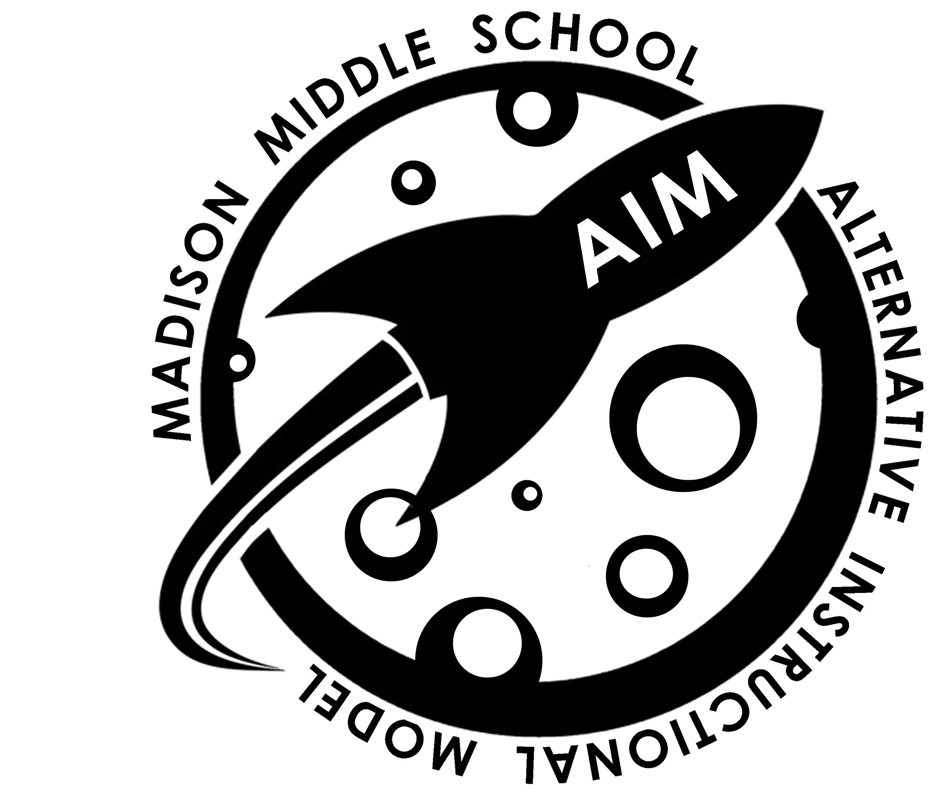
HELP NEEDED – What kinds of help will you need from teachers or parents?
______________________________________________________________________________________________________________________________________________________________________________________________________
Parent signature _____________________________ Date ___________
Teacher signature ____________________________ Date ___________

